# Introduction

Savannas, a terrestrial biome characterized by trees in a matrix of grasses, comprise 20% of the world’s land area (Scholes and Archer 1997). Savannas occur on every continent except Antarctica and often have high plant and animal diversity (Sarmiento 1984). They provide significant carbon sinks and contribute to human livelihoods through, among other ways, nature based tourism and pastoralism (Scurlock and Hall 1998, Grace et al. 2006). Despite their importance, the processes that contribute to their existence continue to be poorly understood.

Savannas are physiognomically distinct from forests, where trees dominate, and grasslands, where grasses dominate. The “savanna problem,” the ongoing debate about how trees and grasses coexist in savannas, has long puzzled ecologists (Sarmiento 1984). Investigations into the mechanisms that control tree / grass competition and coexistence date back to the early 20th century, and have coalesced into two broad explanations: niche partitioning and disturbance (Scholes and Archer 1997, Ward et al. 2012). In the former, trees and grasses differentially access nutrients and water, supporting equilibrium (Ward et al. 2012). In the latter, a disequilibrium model, disturbances such as fire, frost, or herbivory serve as bottlenecks that favor grasses, which are more protected from the effects of fire, at the expense of woody plants (Scholes and Archer 1997, Higgins et al. 2000, Holdo 2007)**.**

Savannas Understanding how fire affects tree-grass interactions in savannas requires an understanding of savanna fire regimes. Fire regimes are the long-term spatial and temporal patterns of fire, and aggregate a number of fire-related metrics. Fire frequency and intensity, two key variables in savanna fire regimes, are known to be positively driven by to precipitation (Govender et al. 2006, Archibald et al. 2010). As rainfall increases, grass biomass increases due to increased growth of grass and (Scholes and Archer 1997). Fire intensity, the rate of energy released by a fire, is driven by a number of factors, including wind, fuel arrangement, fuel load, fuel moisture, etc. (Rothermel 1972). In areas where grass is the primary carrier of fire, fire intensity tends to increase with grass biomass, which also increases with rainfall(Scanlon et al. 2005, Govender et al. 2006). Although fire frequency and fire intensity are generally considered inversely related (frequent fires reduce fuel accumulation and thus the potential for high intensity fires), in savannas, both tend to increase with rainfall due to the effect of increased grass production and fuel continuity (Govender et al. 2006).

Frequent, intense fires can ‘trap’ savanna trees in a persistent subadult state by causing topkill, the aboveground mortality of woody tissue(Hoffmann and Solbrig 2003, Higgins et al. 2012). These trees grow, are topkilled by fire, and resprout; this cyclic process is known as ‘the fire trap’ (Higgins et al. 2000, Bond and Midgley 2001). Trees caught in the ‘fire trap’ are rarely killed, but instead persist in this cycle of growth, aboveground mortality, and resprouting (Hoffmann et al. 2009). The fire trap can partially explain the abundance of small trees in savannas and the comparative scarcity of larger trees (Grady and Hoffmann 2012). Given the right conditions (*i.e*., occasional fire-free windows), trees can escape this trap to grow into adult size classes, but it is not clear how sensitive the probability of escape from the fire trap is to variation in tree growth rates and fire regime dynamics (Gignoux et al. 1997, Bond et al. 2012, Werner 2012).

Topkill, and thus the likelihood of escaping the fire trap, is a function of tree growth rates and fire (Higgins et al. 2000, Lawes et al. 2011, Grady and Hoffmann 2012). Trees must grow sufficiently during fire free periods to reach a height outside of the flaming depth in order survive a fire (Dantas and Pausas 2013). Growth is thought to generally increase with precipitation, and the critical height for surviving a fire in southern African savannas is considered to be ≥ 3 m, although this varies in other tropical and temperature savannas (Bond and Midgley 2001, Grady and Hoffmann 2012, Dantas and Pausas 2013). Although bark thickness and other factors do play a role in survivability, height is often considered the *sine qua non* for survival(Bond and Midgley 2001, Dantas and Pausas 2013).

All of the factors related to understanding how trees escape the fire trap (growth, fire frequency, and fire intensity) may vary and interact across rainfall gradients, but this has not been directly investigated to date. Understanding this relationship is particularly important because of the general understanding that fire and other disturbances are more important at controlling woody cover in wetter savannas and resource limitation is more important in controlling woody cover in drier savannas (Sankaran et al. 2005). If this is true, we would expect the probability of escape to decrease in wetter savannas and increase in drier savannas.

We seek to understand how multiple rainfall-linked processes interact to control the probability of a tree escaping the fire trap across a range of mean annual rainfall. In order to do so, we model fire frequency, fire intensity, and tree growth. By doing so, investigate how do these factors interact to affect the likelihood of a tree escaping the cycle of fire-induced topkill and “escape the fire trap”.

This model investigates three potential scenarios: a) “fast growers outlast”, b) “intensity trumps all”, and c) “frequency beats intensity”. In the former, growth is the primary driver of escape. Those species that are able to grow faster under certain environmental constraints, whether in drier or wetter areas, are the ones that are more likely to escape the “fire trap,” independent of fire frequency or intensity. Alternatively, fire intensity may be the primary driver: growth may be overwhelmed by high frequency, low intensity or infrequent, high intensity fires. In that scenario, fire free intervals allow the potential for tree recruitment. Lastly, because of the wide range of intensities possible independent of fire frequency, we note the possibility that fire frequency, not intensity, is the primary factor limiting tree recruitment.

# Methods

## Study System

Kruger National Park serves as an ideal study system for questions of savanna fire ecology due to its wide range of MAR and ongoing monitoring of fire. Kruger NP is located in eastern South Africa, sharing its eastern borders with Mozambique and northern border with Zimbabwe. The park is over 2 million ha, and spans 350 km from north to south. A north-south rainfall gradient spans the park, peaking at 950 mm yr-1 in the southwest and < 400 mm yr-1 at Pafuri in the northeast (Mabunda et al. 2003). The park’s soils vary in productivity based on their parent material: in the west, low fertility granite, and to the east, high fertility basalt (Mabunda et al. 2003).

Fire is common in Kruger NP, and much of it is anthropogenic in origin (Van Wilgen et al. 2000). Fires vary in seasonality, intensity, and frequency, and are used by Kruger NP managers to meet specific and general objectives (Govender 2003, Govender et al. 2006). Kruger National Park is also home to a long-term experiment that manipulates fire frequency and seasonality across a rainfall gradient (Biggs et al. 2003). This experiment is ongoing, having started in 1954. During each treatment, weather conditions and fire behavior are recorded.

The wide rainfall gradient at Kruger National captures much of the range of many of the savannas of sub-Saharan Africa (Figure 1). This makes Kruger an appropriate unit of analysis for understanding the drivers and patterns present in savannas across the continent.

## Model description

The model tracks growth and fire-induced topkill within cohorts of trees occurring at different points along a given mean annual rainfall (MAR) gradient (Fig. 2). Trees growth is as a function of MAR (Higgins et al. 2000). For each model run, a MAR is assigned to each tree within a cohort and a corresponding distribution of mean fire return intervals. Each year, the occurrence of a fire is determined by sampling from a binomial distribution with a probability equal to the inverse of the sampled mean fire return interval (i.e., the fire frequency (fires yr-1)). If a fire occurs, the intensity of the fire is calculated as a function of MAR, and the probability of topkill for each stem is a function of tree height and fire intensity (Higgins et al. 2012). Topkilled trees are reset to a height of 0 and resprout the next year, continuing to grow.

## Tree growth

We compared three different potential growth scenarios with regard to rainfall: positive, negative, and flat. The initial scenario was first outlined in Higgins et al. (2009) and described a general increase in growth rates (height increments, cm yr-1) across a rainfall gradient. This growth relationship was generalized from a study across South Africa (Shackleton 1997). We fit a linear model to this relationship so that we could predict growth rates anywhere along the curve.

Although generally growth is considered to increase with rainfall, we sought to also explore a potential negative relationship. To parameterize it, we searched the available literature for diameter and height increments for a known dry site specialist, *Colophospermum mopane* (Cowling et al. 1997). We hypothesized that because of their range limitation, decreased growth rates in areas of increased MAR would be observed. Where necessary, we converted diameter increments into height increments using allometric relationships obtained from Kruger National Park trees (K. Cummings, unpublished data).

For the null relationship, we combined growth rates used in the calibration of the negative and positive models and generated a sequence of values between the lowest and highest growth rates. We then fit a generalized linear model to them that assumes no relationship with rainfall.

To estimate changes in height, we used the same differenced growth rate established by Higgins (2012):

[1]



where *h* is tree height (cm), *h*y-1 is height (cm) in the previous year, *h*max is the maximum (asymptotic) height (cm), and gs is growth rate (cm yr-1). We held *h*max at the same value as Higgins (2012), 600 cm.

## Fire frequency

Gridded mean annual rainfall from *worldclim* was overlaid across a raster layer of mean fire return interval (MFRI) for Kruger National Park, South Africa (Hijmans et al. 2005, Smit et al. 2012). Smit et al. (2012)mapped fire extents from a 65-year period in KNP to calculate mean fire return interval. We modeled MFRI as a function of MAR by fitting a generalized linear model (glm) with a gamma distribution and a log link function. We compared this to a null model (MFRI ~ 1) and selected based on a likelihood ratio test as well as analyses of model suitably plots. We calculated the 95% confidence interval of the relationship between MFRI and MAR and sampled within this space for values relating this bivariate relationship. We were thus able to capture the variation in fire return intervals as a function of rainfall, which has been noted as important in providing opportunities for tree escape (Smit et al. 2010)

## Fire intensity

After analyzing the results of the ongoing Kruger National Park experimental burn program, Govender et al. (2006) found a positive relationship between MAR and Byram’s fireline intensity. Fire intensity was calculated from a 30 year dataset from Kruger National Park’s Experimental Burn Plots. Byram’s fireline intensity was calculated using *I = Hwr*, with *I* being intensity (kW m-1), *H* is the known energy content of the grasses at Kruger National Park (16,890 J g-1), *w* is the grass biomass in the plot (kg ha-1), and *r* is the rate of spread of the head fire (Byram 1959, Govender et al. 2006).

We reanalyzed this relationship by fitting a generalized linear model in the base *stats* package (R Core Team 2015). We related the previously calculated Byram’s fireline intensity to MAR at the site using a gamma distribution for the response variable (fireline intensity). We also calculated a null model (Fireline intensity ~ 1) that assumes no connection between fireline intensity and MAR. After assessing plots of model fit, we compared these two models with likelihood ratio tests, and…?

## Probability of topkill and probability of escape

The probability of topkill per tree per year is assumed to be a function of stem height (H) and fireline intensity (I), following Higgins et al. (2012)

(Eqn. 2): [2]



Here, y is topkill probability, S is… etc. Their model was calibrated on a multi-species dataset of monitored individuals of contrasting height in the Experimental Burn Plots at Kruger National Park. After an experimental fire treatment, individual-level topkill was recorded and associated with the Byram’s fireline intensity of the fire. Higgins et al. included season (S) as a covariate in their model; we hold this constant as a dry season fire. We parameterized the model with the general, non-species specific β terms, respectively -3.9, 0.05, 0.3, and 1.

We calculate probability of escape by assessing the proportion of trees that grew to heights greater than 3 m per model run for each bracket.

## Sensitivity analysis

Following runs of our default model, we conducted a simple test to determine the extent to which the observed escape vs. MAR relationship was driven by associations between MAR and tree growth, fire frequency, or fire intensity.We decoupled the relationships between MAR and each of these variables in turn (by using the intercept models for each variable), and reran the escape model. We then compared the predicted probability of escape across rainfall gradients between the standard model and the three MAR-decoupled models using R2.

# Results

## Growth rates

Linear models were fit to growth rate increments as a function of rainfall (Figure 3). *Colophospermum mopane* growth rates were identified from a number of sources and sites and calibrated to estimate height increments (Appendix T1, Figure 3) (Mushove et al. 1995, Worbes 1999)

## Mean fire return interval

Mean fire return interval (MFRI) was shown to generally increase with MAR. Using maximum likelihood estimation, a Gamma distributed model was fit to the relationship between MFRI and MAR (Figure 4). When tested with a likelihood ratio test, this fit significantly better than a null model (MFRI ~ 1, χ2 (1, 24136) = 1672.6, p ≤ 0.01). Fire frequency was calculated as the inverse of MFRI, *i.e.* 1 / MFRI.

## Fire intensity

A Gamma distribution was found to be a good fit for the fire intensity data, and fit better than normal or log-normal. Maximum likelihood estimation was used to fit fire intensity data to MAR for the Experimental Burn Plots (Figure 5). A likelihood ratio test showed that fire intensity estimations as a function of MAR produced significantly better fits than a null model (Fire Intensity ~ 1, χ2 (1, 1235) = 26.809, p ≤ 0.01), and the relationship was positive. As the model ran, fire intensity distributions were simulated for any input MAR from the model.

## Model sensitivity

We tested the effects of only varying one variable with rainfall and fit linear models with the standard model predictions as a response variable (i.e., Standard ~ Alternate Model). The model in which MFRI is the only rainfall linked trait explained the greatest amount of the variation in the standard model, followed by intensity and growth (Figure 6, Table 3). This variation also had clear effects on the probability of escaping the fire trap (Figure 7).

## Effect of growth responses

When growth was varied relative to rainfall (positive, negative, and null response), probability of escape also varied (Figure 8). All trees, regardless of sensitivity of growth response to rainfall, showed decreases in probability of escape in areas of higher rainfall. Trees that grew slower with more rainfall were more likely to not escape topkill with more rainfall. Even trees with flat responses to rainfall showed decreased probability of escape at higher rainfalls.

# Discussion

We sought to model the impact of variation in mean annual rainfall on the interactions of tree growth, fire intensity, and fire frequency. We used these interactions to predict how probability of a tree escaping the fire trap might vary with rainfall under different scenarios.

We predicted three competing scenarios to explain the observed outcomes. One scenario focused on the importance of tree growth, the second focused on fire intensity, and the third focused on the importance of fire frequency. The results of the sensitivity analysis suggest support for the third scenario. *Ceteris paribus*, the rainfall-linked variable that explains the most variation in the final model is mean fire return interval (Figure 6, Table 3). Growth explains the least amount of variation in the final model, with intensity explaining a great deal but a significantly less amount of variation than MFRI (Figure 6, Table 3).

The results of the sensitivity analysis were also intuitive. When only tree growth rates varied with rainfall, probability of escape increased with MAR. Conversely, when only intensity or MFRI varied with rainfall, probability of escape decreased with MAR. The rate of decreased probability of escape is greater when MFRI varies with MAR than when intensity varies with MAR, suggesting the importance of frequency over intensity.

Variation the growth rate response relative to rainfall produced surprising results (Figure 8). Under all scenarios, probability of escape decreased with increased mean annual rainfall. Probability of escape was consistently highest when growth rates responded positively to rainfall. When growth rates responded negatively to rainfall, probability of escape was slightly greater under lower rainfall conditions (400 – 600 mm yr-1) than predicted from positive growth rates. When growth was decoupled from rainfall (Growth ~ 1), the probability of escape still decreased with MAR, but the rate of decrease was much greater. The overall decrease in probability of escape as rainfall increases suggests that probability of escape as modeled is largely insensitive to growth: positive, negative, or unlinked, all scenarios show decreases in probability of escape.

Previous literature has emphasized the importance of growth rates for escaping fire (Bond and Midgley 2001, Werner 2012, Higgins et al. 2012, Dantas and Pausas 2013), though largely from a theoretical perspective. Compared to many areas, savanna tree growth rates are understudied. This in part due to difficulties in measuring tree rings in many tropical trees and an otherwise paucity of dendrometer studies (Lilly 1977, Worbes 1995). Lacking this quantitative basis, we are limited in our understanding of how growth rates affect tree dynamics in savannas.

Our model suggests that probability of escape is highly sensitive to mean fire return intervals and largely decoupled from intensity and growth rates. Intensity can vary a great deal within a MAR scenario, which may drive this weak linkage. Weather (wind, relative humidity, etc.) and fuel moisture scenarios greatly affect fire behavior and consequently fire intensity, even when combustible fuel is held constant (Rothermel 1972, Trollope and Potgieter 2010). It is possible to see a wide variety of different fire intensities even with the same fuel load, which may account for the variation in intensities found within the EBPs sampled.

Our study, along with many others on savanna fire dynamics, may be biased by the Experimental Burn Plots. The commonly cited relationships between fire weather variables and fire intensity, as well as the relationship between intensity and topkill, are all derived from experimental burns (*e.g.*, Govender et al. 2006, Higgins et al. 2000, Higgins et al. 2012, etc.). These prescribed fires upon which these studies are based are naturally more conservative than wildfires. Fire managers are more likely to light fires on days where control is easy; this necessarily excludes days with lower relative humidity, higher wind speeds, or lower fuel moistures across size classes. Thus the sampling space is biased towards more tame fires. Although there have been recent efforts to experiment with higher intensity fires in savannas, the bulk of the literature focuses on fires of relatively lower intensity (Browne and Bond 2011). These fires may be of little impact to highly fire adapted species such as savanna trees; only larger, more intense fires may provide the “heavy lifting” to truly affect tree dynamics

Empirical descriptions of the effects of fire frequency and rainfall on tree dynamics show a variety of results (Shackleton and Scholes 2000, Higgins et al. 2007, Smit et al. 2010, Shackleton and Scholes 2011). After sampling at one of the more arid Experimental Burn Plots (Satara), Shackleton and Scholes (2000**)** found tree heights decreased with fire frequency. Higgins et al. (2007) found similar results, noting that fire frequency affects tree biomass and structure, but not density. This was supported by Smit et al. (2010), who found that fire had greater absolute effects at reducing biomass in wetter, denser savannas, but relative effects were greater in drier sites. Across a rainfall gradient from 484±32 – 1161±225, Shackleton and Scholes (2011) found evidence for increasing tree biomass, density, and height with increasing MAR. Interestingly, our modeled decreases in probability of escape occur around 650 mm yr-1 MAR, which is also approximately the cutoff between drier, resource limited savannas and wetter, disturbance limited savannas (Sankaran et al. 2005) Overall, these support our general findings that fire limits tree recruitment more in wetter savannas than in drier savannas as well as the observed effects of fire frequency.

A key element that is not included in this model, and remains a difficult component to include, is the interacting roles of fire and herbivores, which has been noted in previous research. Tree growth rates in both dry and wet savannas have been shown to increase when herbivory was reduced (Staver et al. 2009, Staver and Bond 2014), thus suggesting that in drier sites, trees may be growth limited by both resource availability and herbivory. Periods of decreased herbivore pressure could thus allow otherwise suppressed woody individuals to escape the fire trap. Similarly, the interactions of elephants and fire has been long shown to increase tree mortality across size classes and change the structural composition of savannas (Baxter 2005, Holdo 2007, Sankaran et al. 2008, Levick et al. 2012, 2014). Interactions between animal populations (and thus herbivore pressure), longer term rainfall patterns, and fire frequency are likely to exist, but the complexity of the interactions may make it difficult to understand in what ways they may provide opportunities for cohort recruitment of trees in savannas.

# Conclusions

Our study supports the general conclusion that fire is more important at controlling woody species in wetter savannas where fires are both more intense and frequent. We raise questions about the overall importance of growth rates in escaping the fire trap, and instead show evidence to support the importance of fire frequency and fire intensity as drivers that control recruitment of trees. Although previous work has focused on these drivers individually, few have integrated them into a model that explicitly addresses the role of mean annual rainfall as a parallel driver of growth, fire frequency, and fire intensity. Ultimately, more research must be done on the factors that control growth rates of savanna trees to truly understand how this may affect tree dynamics. This remains a key area in which we still know vary little, yet is crucial to our understanding of this important biome.

# Acknowledgements

We would like to thank Navashni Govender, Scientific Services, Kruger National Park, as well as the rest of the staff their for their support in our data analysis efforts.

Tables

Table 2. Model preset values.

|  |  |
| --- | --- |
| **Parameter** | **Value** |
| Runs | 5000 |
| Trees | 500 |
| Time Limit | 50 |

Table 3. Model Sensitivity Results

|  |  |  |
| --- | --- | --- |
| **Model** | **R2** | **AIC** |
| Standard ~ Only MFRI Varies with Rainfall | 0.98 | -358.2410 |
| Standard ~ Only Intensity Varies with Rainfall | 0.95 | -285.9417 |
| Standard ~ Only Growth Varies with Rainfall | 0.75 | -201.2866 |

# Figures

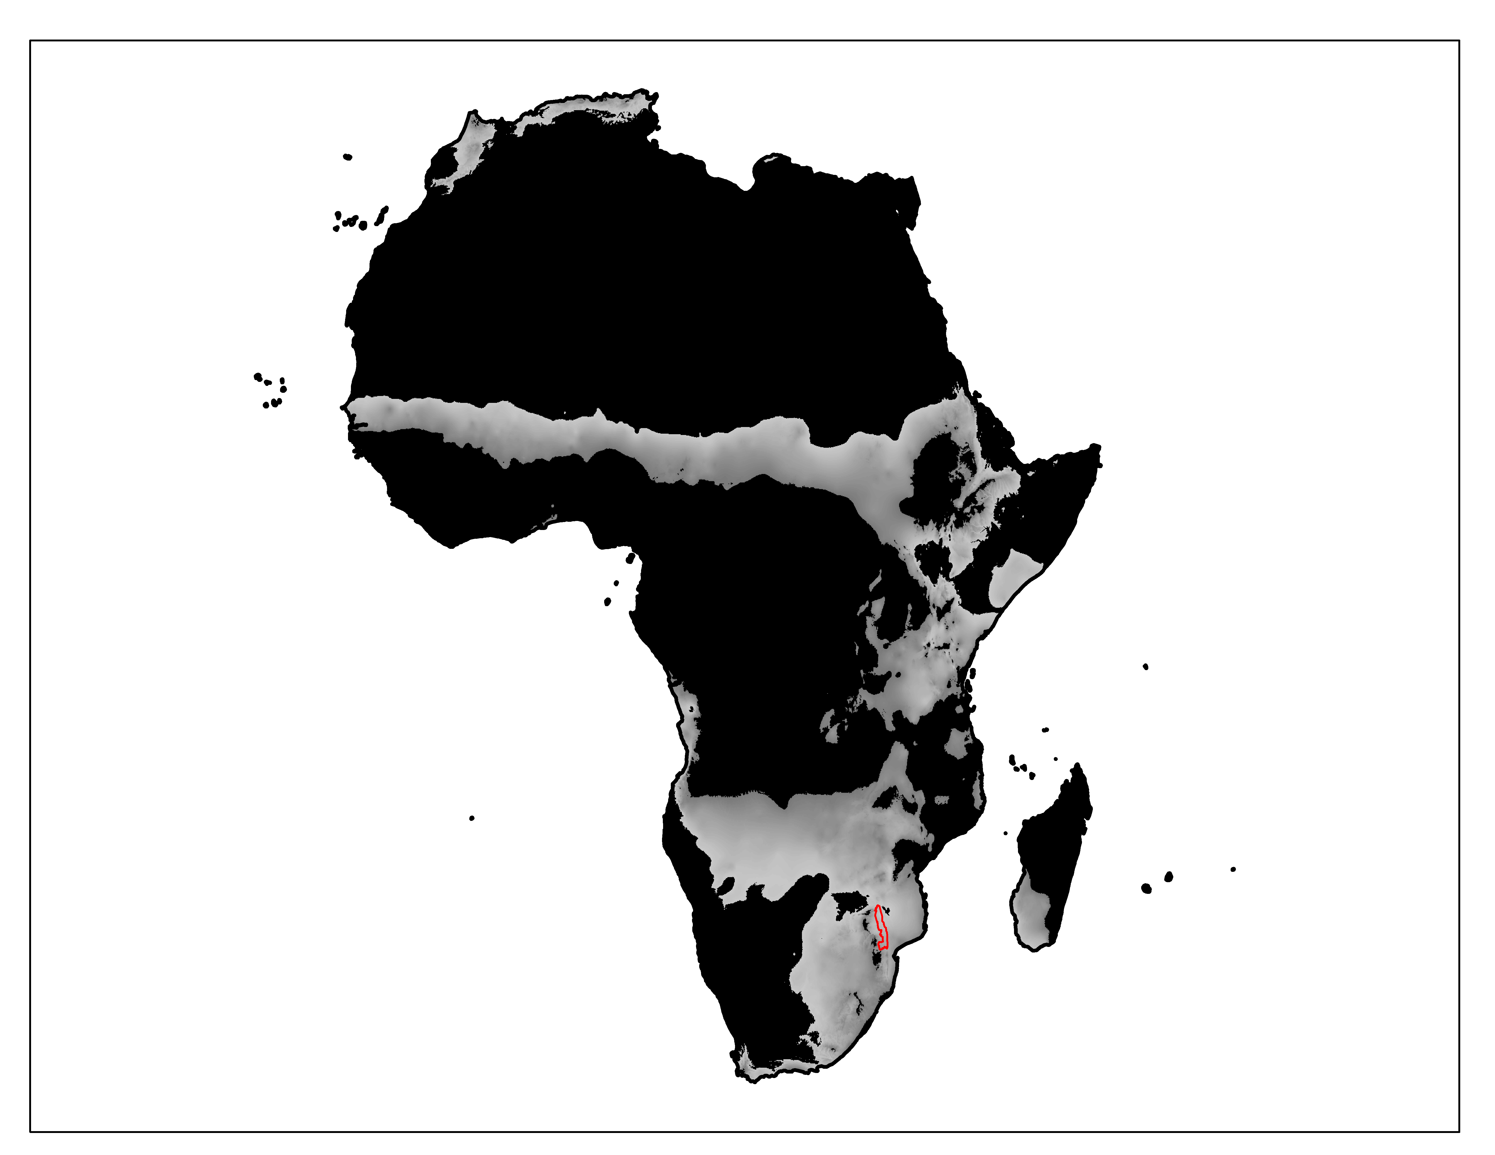Figure 1. Kruger National Park, South Africa (red) serves as an ideal model system for capturing rainfall-linked variation across the savanna biome in Africa by spanning a wide mean annual precipitation gradient (gray, 450 – 900 mm yr-1). Precipitation data from *worldclim.*

Fire Regime

MAR

Frequency

Intensity

Tree growth

Topkill

Escape

Figure 2. Model flowchart. Model links fire frequency, fire intensity, and growth to probability of topkill, and thus probability of escaping the fire trap. Green lines are positively linked variables. Red lines are negatively linked variables.



Figure 3. Samples (points) and linear models (lines) fit to A) positive growth rates (y = 0.04x + 21.4, R2 = 0.99, F1,2 = 236.7, p ≤ 0.01) and B) *Colophospermum mopane* negative rainfall-linked growth rates (y = 0.05 + 101.6, R2 = 0.74, F1,4 = 11.56, p = 0.02). Models were predicted across the rainfall area of interest, 450 – 900 mm yr-1. Gray areas show 95% CI.



Figure 4. Estimated mean fire return intervals as a function of MAR (gray) and the true values as extracted from Smit et al. (2012) and *worldclim*.

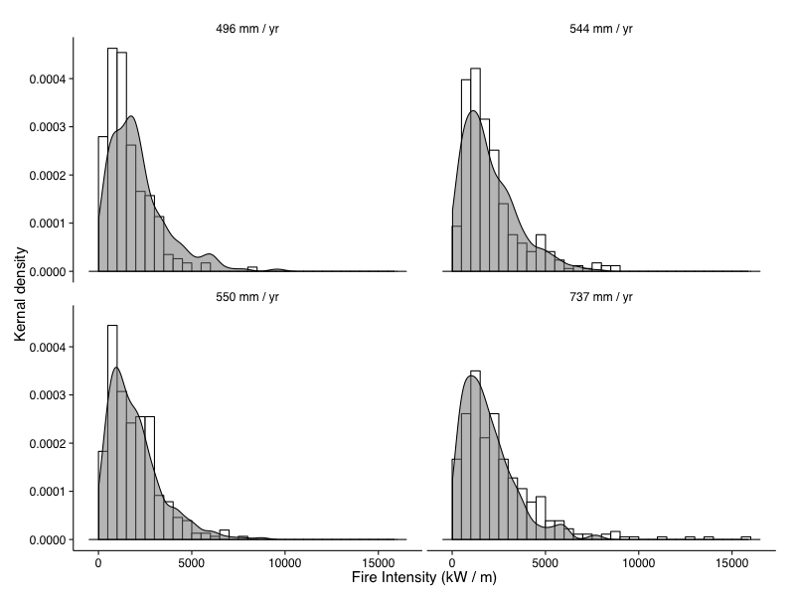

Figure 5. Estimated distributions Byram’s fireline intensity (gray) and the true values (white) as recorded by the four different sites of varying rainfall.



Figure 6. Sensitivity analysis. Solid lines indicate the 1:1 relationship between the standard model predictions. The dashed lines show the relationship between models in which only one variable is linked to rainfall and the standard model.



Figure 7. Predictions from sensitivity analysis. In comparison to the standard model (A), model was rerun with only (B) MFRI, (C) intensity, and D) growth rates varying with rainfall. Dashed lines are 95% CI of predictions.



Figure 8. Variation in probability of topkill as a function of rainfall with three different growth-responses relative to rainfall. A) Growth rate response is positive with rainfall. B) Growth rate response is negative with rainfall, from *Colophospermum mopane* data. C). Growth rate response is decoupled from rainfall. All other variables (MFRI and intensity) also vary with rainfall. Dotted lines are 95% CI of predictions.

# Works Cited

Archibald, S., A. Nickless, N. Govender, R. J. Scholes, and V. Lehsten. 2010. Climate and the inter-annual variability of fire in southern Africa: a meta-analysis using long-term field data and satellite-derived burnt area data. Global Ecology and Biogeography 19:794–809.

Baxter, P. 2005. A model-framed evaluation of elephant effects on tree and fire dynamics in African savannas. Ecological Applications.

Biggs, H. C., T. T. Dunne, and N. Govender. 2003. Experimental burn plot trial in the Kruger National Park: history, experimental design and suggestions for data analysis. Koedoe 46:1–15.

Bond, W. J., and J. J. Midgley. 2001. Ecology of sprouting in woody plants: the persistence niche. Trends in Ecology & Evolution 16:45–51.

Bond, W. J., G. D. Cook, and R. J. WILLIAMS. 2012. Which trees dominate in savannas? The escape hypothesis and eucalypts in northern Australia. Austral Ecology 37:678–685.

Browne, C., and W. J. Bond. 2011. Firestorms in savanna and forest ecosytems: curse or cure? Veld & Flora 97.

Dantas, V. de L., and J. G. Pausas. 2013. The lanky and the corky: fire-escape strategies in savanna woody species. Journal of Ecology 101:1265–1272.

Gignoux, J., J. Clobert, and J. C. Menaut. 1997. Alternative fire resistance strategies in savanna trees. Oecologia 110:576–583.

Govender, N., W. S. W. Trollope, and B. Van Wilgen. 2006. The effect of fire season, fire frequency, rainfall and management on fire intensity in savanna vegetation in South Africa. Journal of Applied Ecology 43:748–758.

Grace, J., J. S. Jose, P. Meir, H. S. Miranda, and R. A. Montes. 2006. Productivity and carbon fluxes of tropical savannas. Journal of Biogeography 33:387–400.

Grady, J. M., and W. A. Hoffmann. 2012. Caught in a fire trap: Recurring fire creates stable size equilibria in woody resprouters. dx.doi.org 93:2052–2060.

Higgins, S., W. J. Bond, and W. S. W. Trollope. 2000. Fire, resprouting and variability: a recipe for grass–tree coexistence in savanna. Journal of Ecology 88:213–229.

Higgins, S., W. J. Bond, E. C. February, A. Bronn, D. I. W. Euston-Brown, B. Enslin, N. Govender, L. Rademan, S. O'Regan, A. L. F. Potgieter, S. Scheiter, R. Sowry, L. Trollope, and W. S. W. Trollope. 2007. Effects of Four Decades of Fire Manipulation on Woody Vegetation Structure in Savanna. Journal of Ecology 88:1119–1125.

Higgins, S., W. J. Bond, H. Combrink, J. M. Craine, E. C. February, N. Govender, K. Lannas, G. Moncreiff, and W. S. W. Trollope. 2012. Which traits determine shifts in the abundance of tree species in a fire‐prone savanna? Journal of Ecology 100:1400–1410.

Hoffmann, W. A., and O. T. Solbrig. 2003. The role of topkill in the differential response of savanna woody species to fire. Forest Ecology and Management 180:273–286.

Hoffmann, W. A., R. Adasme, M. Haridasan, M. T de Carvalho, E. L. GEIGER, M. A. B. Pereira, S. G. GOTSCH, and A. C. FRANCO. 2009. Tree topkill, not mortality, governs the dynamics of savanna–forest boundaries under frequent fire in central Brazil. Journal of Ecology 90:1326–1337.

Holdo, R. M. 2007. Elephants, fire, and frost can determine community structure and composition in Kalahari woodlands. Ecological Applications 17:558–568.

Lawes, M. J., H. Adie, J. Russell-Smith, B. Murphy, and J. J. Midgley. 2011. How do small savanna trees avoid stem mortality by fire? The roles of stem diameter, height and bark thickness. dx.doi.org 2:art42.

Levick, S. R., C. A. Baldeck, and G. Asner. 2014. Demographic legacies of fire history in an African savanna. Functional Ecology.

Levick, S. R., G. Asner, and I. P. J. Smit. 2012. Spatial patterns in the effects of fire on savanna vegetation three-dimensional structure. Ecological Applications 22:2110–2121.

Lilly, M. A. 1977. An assessment of the dendrochronological potential of indigenous tree species in South Africa. Department of Geography and Environmental Studies, University of the Witwatersrand.

Mushove, P. T., J. Prior, C. Gumbie, and D. F. Cutler. 1995. The effects of different environments on diameter growth increments of< i> Colophospermum mopane</i> and< i> Combretum apiculatum</i>. Forest Ecology and … 72:287–292.

R Core Team. 2015. R: A Language and Environment for Statistical Computing. Vienna, Austria.

Rothermel, R. C. 1972. A mathematical model for predicting fire spread in wildland fuels. Pages 1–48. Intermountain Forest and Range Experiment Station, US Forest Service, US. Department of Agriculture, Ogden, Utah 84401.

Sankaran, M., J. Ratnam, and N. P. Hanan. 2008. Woody cover in African savannas: the role of resources, fire and herbivory. Global Ecology and Biogeography 17:236–245.

Sankaran, M., N. P. Hanan, R. J. Scholes, J. Ratnam, D. J. Augustine, B. S. Cade, J. Gignoux, S. Higgins, X. Le Roux, F. Ludwig, J. Ardo, F. Banyikwa, A. Bronn, G. Bucini, K. K. Caylor, M. B. Coughenour, A. Diouf, W. Ekaya, C. J. Feral, E. C. February, P. G. H. Frost, P. Hiernaux, H. Hrabar, K. L. Metzger, H. H. T. Prins, S. Ringrose, W. Sea, J. Tews, J. Worden, and N. Zambatis. 2005. Determinants of woody cover in African savannas. Nature 438:846–849.

Sarmiento, G. 1984. The ecology of neotropical savannas. Harvard University Press.

Scanlon, T. M., K. K. Caylor, S. Manfreda, S. Levin, and I. Rodriguez-Iturbe. 2005. Dynamic response of grass cover to rainfall variability: implications for the function and persistence of savanna ecosystems. Advances in Water Resources 28:291–302.

Scholes, R. J., and S. Archer. 1997. Tree-Grass Interactions in Savannas. Annual Review of Ecology and Systematics 28:517–544.

Scurlock, J., and D. O. Hall. 1998. The global carbon sink: a grassland perspective. Global Change Biology.

Shackleton, C. M. 1997. The Prediction of Woody Productivity in the Savanna Biome, South Africa.

Shackleton, C. M., and R. J. Scholes. 2000. Impact of fire frequency on woody community structure and soil nutrients in the Kruger National Park. Koedoe.

Shackleton, C. M., and R. J. Scholes. 2011. Above ground woody community attributes, biomass and carbon stocks along a rainfall gradient in the savannas of the central lowveld, South Africa. South African Journal of Botany 77:184–192.

Smit, I. P. J., G. Asner, and N. Govender. 2010. Effects of fire on woody vegetation structure in African savanna. Ecological ….

Staver, A. C., and W. J. Bond. 2014. Is there a “browse trap?” Dynamics of herbivore impacts on trees and grasses in an African savanna. Journal of Ecology 102:595–602.

Staver, A. C., W. J. Bond, W. D. Stock, S. J. van Rensburg, and M. S. Waldram. 2009. Browsing and fire interact to suppress tree density in an African savanna. dx.doi.org 19:1909–1919.

Trollope, W. S. W., and A. L. F. Potgieter. 2010. Fire behaviour in the Kruger National Park. dx.doi.org 2:17–22.

Ward, D., K. Wiegand, and S. Getzin. 2012. Walter’s two-layer hypothesis revisited: back to the roots! Oecologia 172:617–630.

Werner, P. A. 2012. Growth of juvenile and sapling trees differs with both fire season and understorey type: Trade‐offs and transitions out of the fire trap in an Australian savanna. Austral Ecology 37:644–657.

Worbes, M. 1995. How to measure growth dynamics in tropical trees a review. IAWA journal 16:337–351.

Worbes, M. 1999. Growth of trees from Namibia–a dendrochronological study. Namibia-Finland Forestry Project.

# Appendix

Table 1. *Colophospermum mopane* annualradial increment measurements, adjusted height increments, the mean annual rainfall in which the samples were collected, and the studies that collected the data.

|  |  |  |  |  |
| --- | --- | --- | --- | --- |
| Site | MAR (mm yr-1) | Mean Diameter Increment (cm yr-1) | Est. Height Increment (cm yr-1) | Citation |
| Chiredzi, ZM | 564 | 0.21 | 74.44 | Mushove et al. 1995 |
| Kadoma, ZM | 780 | 0.17 | 63.12 | Mushove et al. 1995 |
| Katima Mulilo, NA | 654 | 0.17 | 60.28 | Worbes 1999 |
| Matapos, ZM | 825 | 0.17 | 60.28 | Mushove et al. 1995 |
| Oshikoto, NA | 504 | 0.22 | 77.98 | Mushove et al. 1995 |
| Zambezi Valley, ZM | 750 | 0.18 | 64.53 | Mushove et al. 1995 |